**4.1 Artificial Intelligence and Organ Transplantation**

Dr Alexander Gimson

<https://www.vanderschaar-lab.com/inspiration-exchange-ml-to-transform-organ-transplantation/>

**Importance of transplantation AI**

* Supply and demand
  + Mortality waiting for liver
  + Limited increase in supply of donor organs
  + Organ donors deteriorating
* Paradigm for scarce healthcare resource
  + Rational approach

**Liver transplantation**

* Only solution for end-stage chronic liver disease
* Multiple causes for end stage liver disease
* 3 year survival without a transplant - 5%
* Good outcome: 94% survival at one year, 75% at 5 year
* Disease Severity, Donor quality can impact outcome
  + Disease severity impact magnified over time
  + Donor quality differences magnified over time
* Allocation principles varies:
  + US– sickest first – Need
    - Risk of poor outcome as disease severity is higher
  + Utility – best outcomes
  + Benefit: net life years gained; UK March 2018

**Why is this a complex interesting area?**

* Multi-dimensional donor and recipient space
  + Upt o 17 donor/recipient factors impact outcome
* Non-linear interactions
  + E.g. Na, K, urea/creatinine, BMI
* Counterfactuals
  + Impact of not receiving a transplants
* Assignment bias
  + Confound by various prejudice decisions and regulatory rules
* Informative censoring
  + Patients on transplant list are censored – never know what the outcome is

**Which areas in transplantation might ML address?**

* Optimal donor organ allocation
  + Organ declining – why
* Clinical variation in offer acceptance rates - quantitative epistemology

**Previous work**

* Spanish group
* SOM

**Organ allocation; principles and considerations**

* Need: sickest patient first
* Utility: best match for outcome
* Benefit:
  + Incremental gain in survival
  + Net life years gained
  + Considerations
    - Time until better organ

**Allocation process**

[Diagram]

**OrganITE**

* **OrganITE: Optimal transplant donor organ offwering using an individual treatment effect**
* <https://papers.nips.cc/paper/2020/file/e7c573c14a09b84f6b7782ce3965f335-Paper.pdf>
* UK Transplant Database:
* Donor organ density
  + 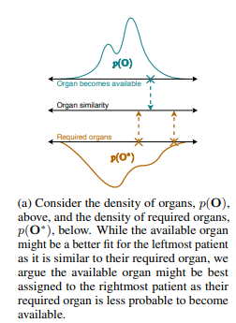
* OrganITE outperform other models
* Importance of organ density
  + During COVID, donor organs became less available
  + Prevalence of donor being available - Temperatur (organ availability)
    - OrganITE is more stable than FIFO, SPF, or BM

**Organboard**

* Demonstrating organ acceptability based on patient data

**Characteristics of patients transplanted by OrganITE and CoxPH**

* Characteristics can be visualized of overall comparing OrganITE and CoxPH
  + Cannot be explored for individual cases – why is one allocated to another?

**OrganSync**

* <https://vanderschaar-lab.com/papers/ICML_2021_OrganSync.pdf>
* 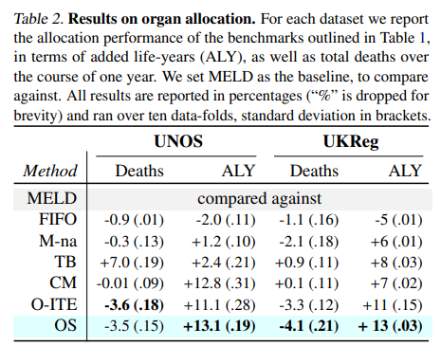
* Based on k-means clustering
  + Each cluster differ by donor feature and recipient parameter
  + Allocation based on the cluster
  + Allowing identification of different clusters
    - Greater granularity of why one is allocated than the other
  + Number of clusters can be adjusted depending on the database size

**Optimal organ allocation processes**

* Outcome without a donor
* Outcome with a specific donor
* Time til another “better/optimal” donor appears

**Clinical variation**

* Variability in clinical care and decisions
* Variance can impact the outcome of transplantation
  + **Liver transplant center variability in accepting organ offers and its impact on patient survival**
  + <https://linkinghub.elsevier.com/retrieve/pii/S0168-8278(15)00773-4>

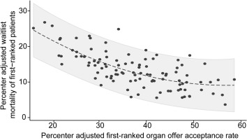

* Identifying drivers of clinical decisions
  + **Closing the loop in medical decision support by understanding clinical decision-making: A case study on organ transplantation**
  + <https://proceedings.neurips.cc/paper/2021/file/c344336196d5ec19bd54fd14befdde87-Paper.pdf>
  + Discover which criteria are most important to clinicians to organ offer acceptance
  + Identify patient-specific organ preferences of centers
  + Explore variations in transplantation practices between different transplant centers.

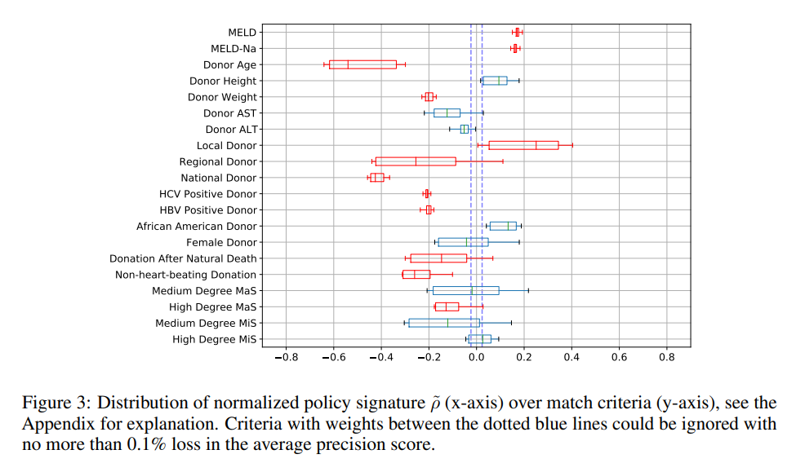

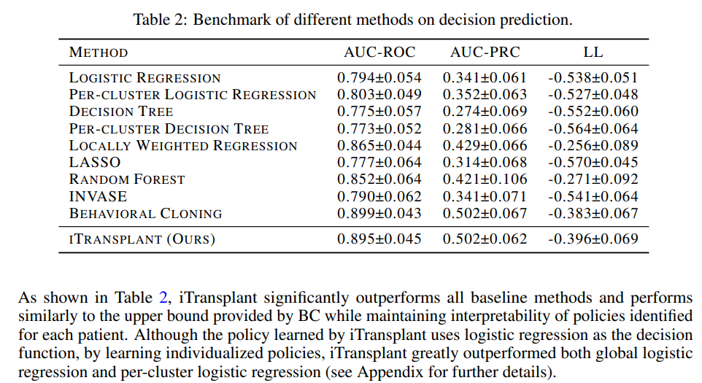

* + - All these parameters have been previously associated with declined donation
      * ITransplant was better in prediction compared to other models
  + ITransplant able to show why clinical decision was different between two centers

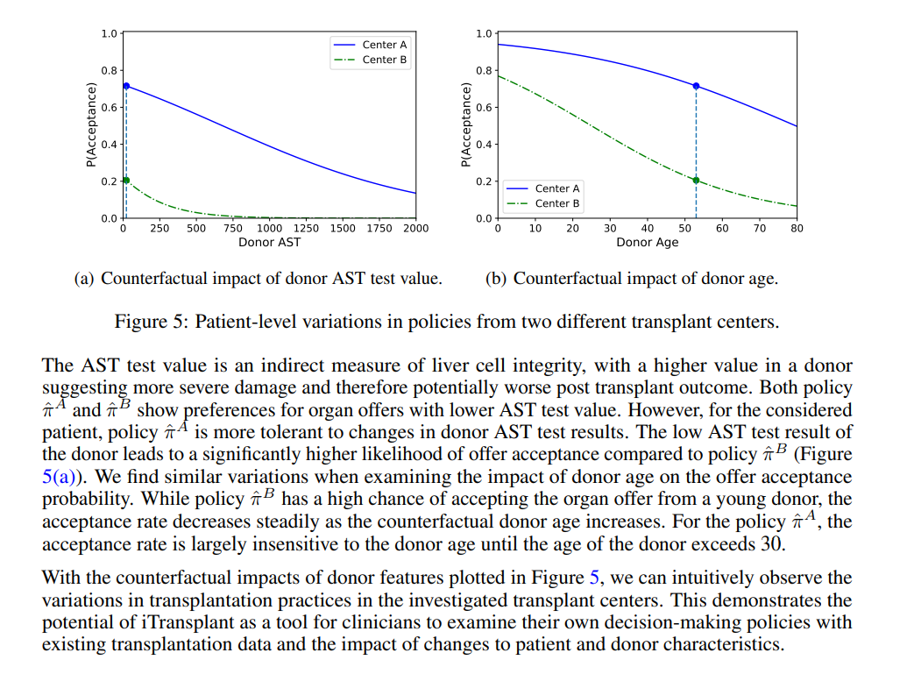

* + Itransplant was able to identify within clusters, why an organ is being accepted or not

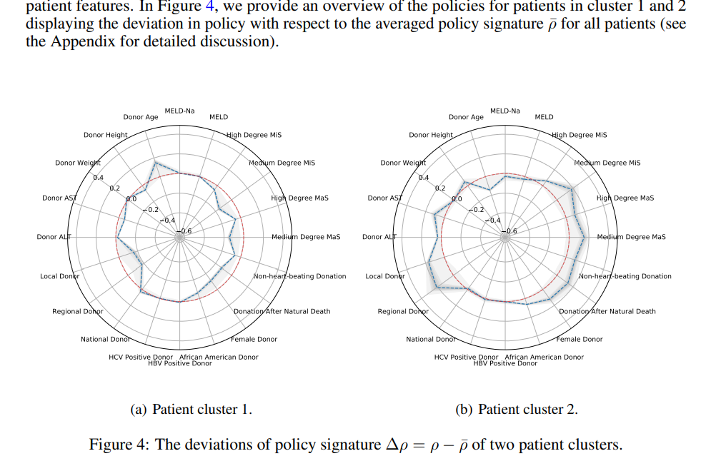

**Implementing ML technologies: lesson from transplantation**

* Implementation of changes with Medicine maybe slow
* Clinical trials of organ allocation have not been undertaken
* Multiple simulations
* Interpretability is only one component of trust in new AI methodologies
* Regulatory authorities
* Public Patient involvement
* Laws of Tort

**Developing, implementing, and governing AI in medicine (Transplantation)**

| Phase 1 | Preparation prior to AI development |  |
| --- | --- | --- |
|  | Define clinical problem |  |
| Evaluate available models |  |
| Collate relevant data, consider bias |  |
| Ensure privacy |  |
| Phase 2 | AI model development |  |
|  | Applicable regulatory requirements |  |
|  | Prepare data |  |
|  | Train & validate |  |
|  | Evaluate performance |  |
| Phase 3 | Asses AI performance & reliability |  |
|  | Externally validate |  |
|  | Simulate results and prepare a clinical study |  |